Benzon Carlitos Salazar

CS412

Week 8: Motors

# About this Assignment:

This assignment will show how to implement three different colored LEDs on an Arduino board.

***A quick note, my DC motor broke, as in, the wires came off of my DC motor, so to remedy that, I have used an alternative output solution with the green LED.***

# Supplies:

* 1 x 830 Tie-Points Breadboard
* 1 x UNO R3 Controller Board
* 1 x DC Motor -- *mine is broken, so as an alternative, I am using a green LED*
* 1 x NPN Bipolar Junction Transistor
* 1 x Diode Rectifier
* 2 x 330Ω Resistor
* 1 x 10KΩ Resistor
* 1 x Button
* 6 x Breadboard Jumper Wires (*+2 more for the LED*)

# The Circuit:

## Connecting the Motor:

First, connect a jumper wire from the 5V pin of your Arduino to the positive horizontal row of your breadboard, and connect another jumper wire from the GND pin of your Arduino to the negative horizontal row of your breadboard.

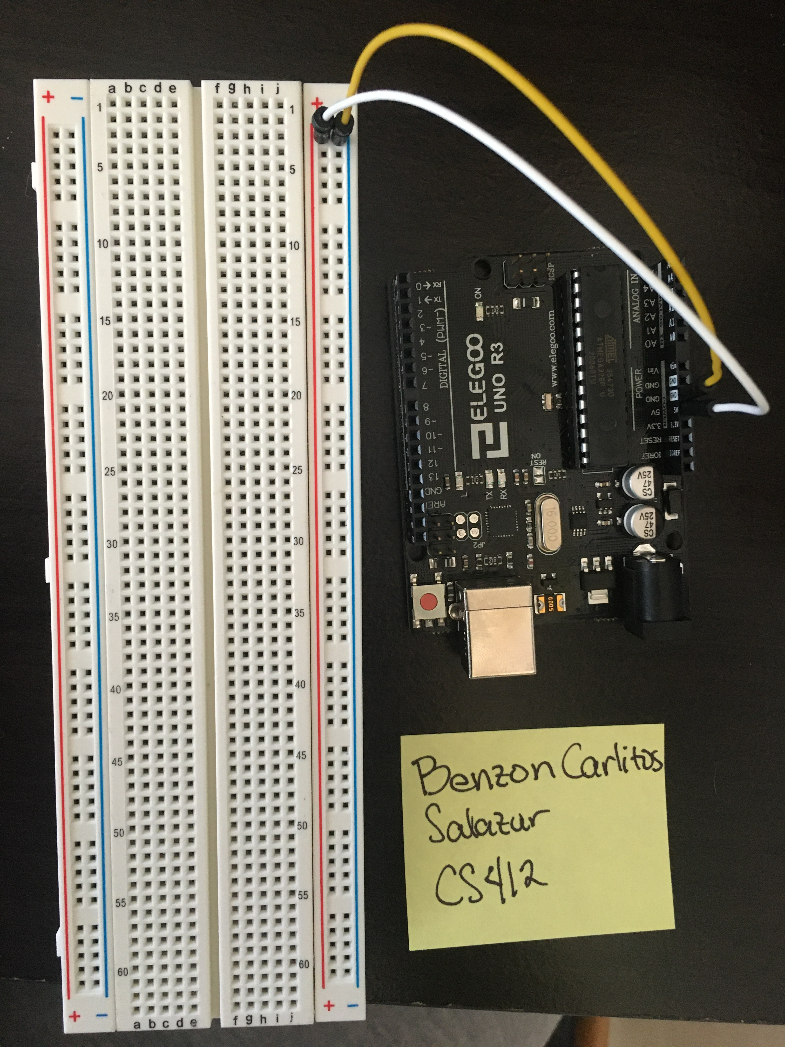

Next, place your transistor on your breadboard, making sure to spread your terminals so that you have room to work. Orient the transistor so that the flat side is facing your right hand side. From this orientation, the bottom terminal is the **Emitter**, the middle terminal is the **Base**, and the top terminal is the **Collector**.

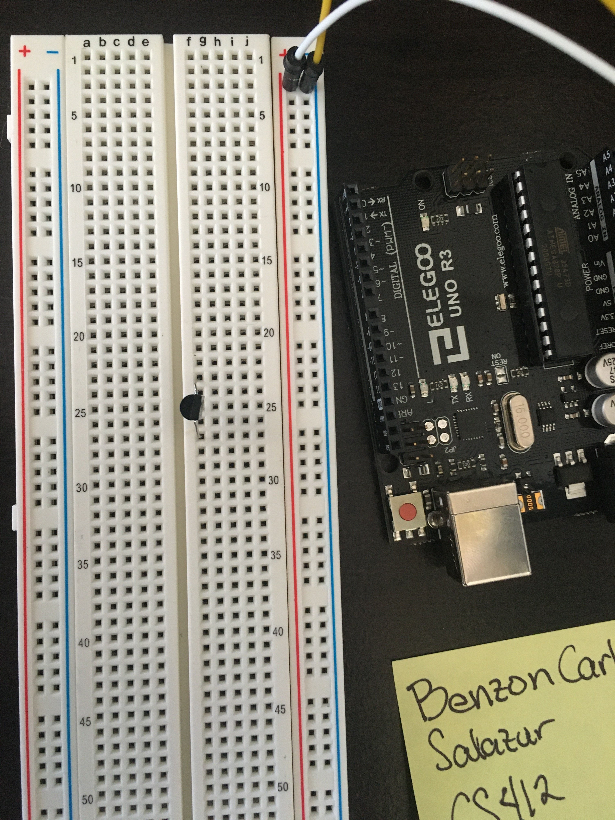

Next, the diode will have polar ends. The cathode (negative end) will have a silver/grey stripe, while the anode (positive end) will not. Attach the diode on your board so that the anode is connected to the Collector terminal of your resistor, and the cathode is connected back to the breadboard.

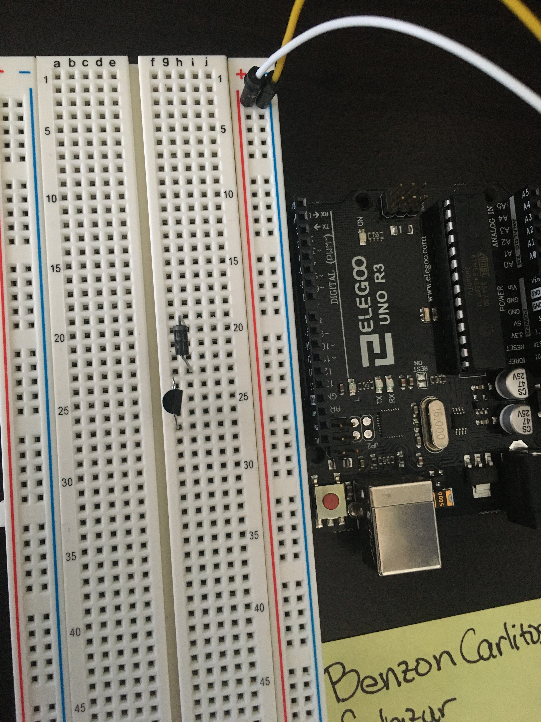

Next, place your first 330Ω resistor on your breadboard so that one terminal is connected to the Base of your transistor, and the other is connected back to the breadboard.

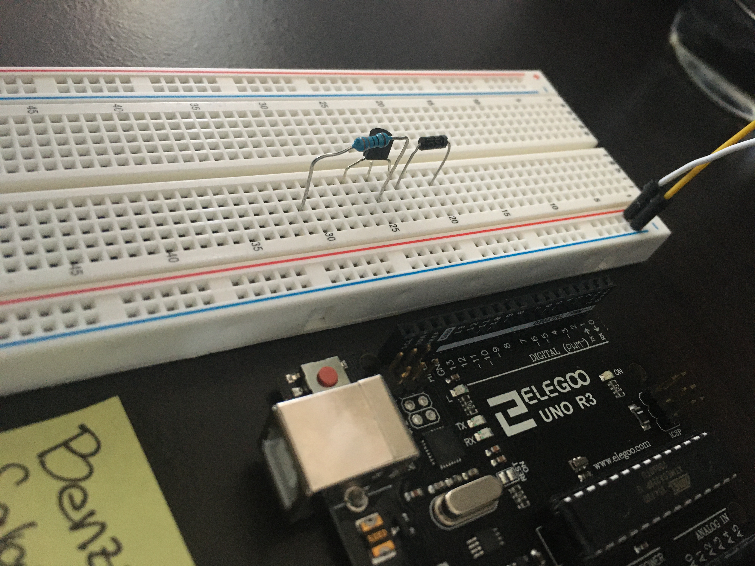

Next, attach your DC motor so that the positive terminal is connected to the negative terminal of the diode, and the positive terminal is connected to the negative terminal of the diode. But since I have a broken DC motor, as an alternative, with two extra jumper wires, a green LED is used. The positive leg of the LED is connected to the negative terminal of the diode, and the negative leg of the LED is connected to the positive terminal of the diode.

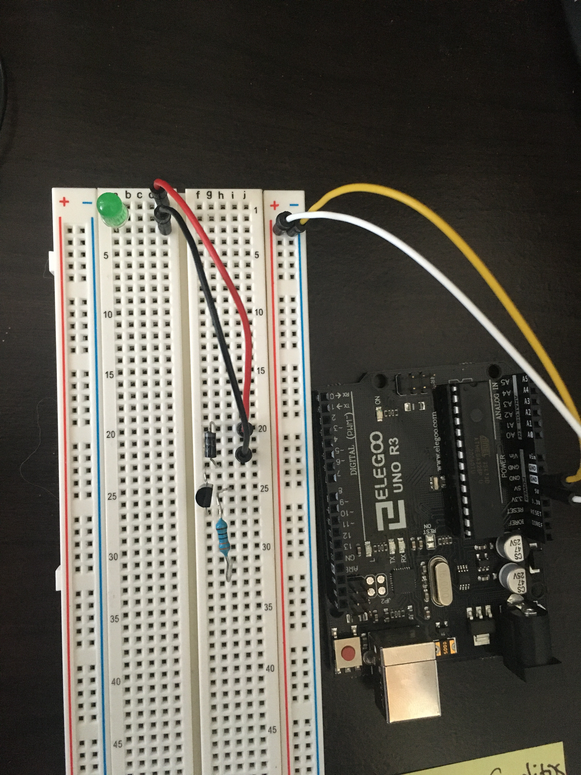

Now finally, using a jumper wire, connect the 5V pin of the UNO board to the negative terminal terminal of the diode. Connect the Emitter terminal of the transistor to ground (GND) using a second 330Ω resistor. And connect the other terminal of the first 330Ω resistor to digital pin 11.

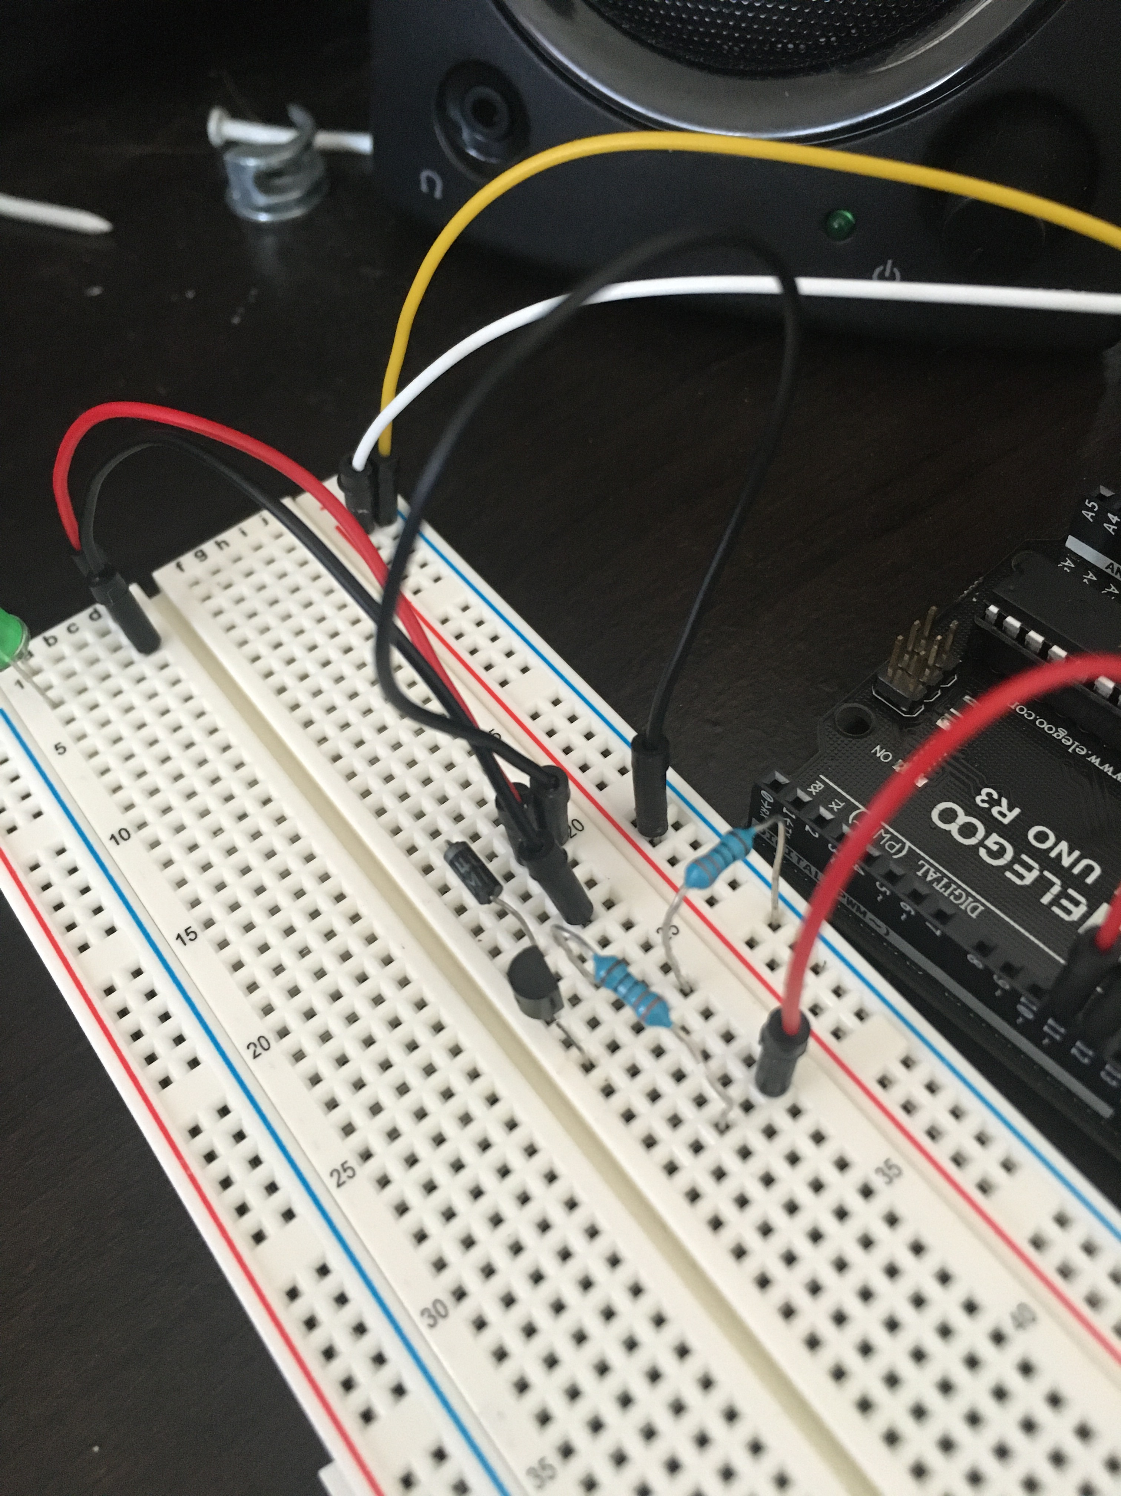

## Connecting the button:

First, place the button on your breadboard. Using a jumper wire, connect digital pin 12 to terminal B (bottom right terminal) of your button. And using the 10KΩ resistor, connect one terminal also to terminal B, and the other terminal of the resistor to the GND.

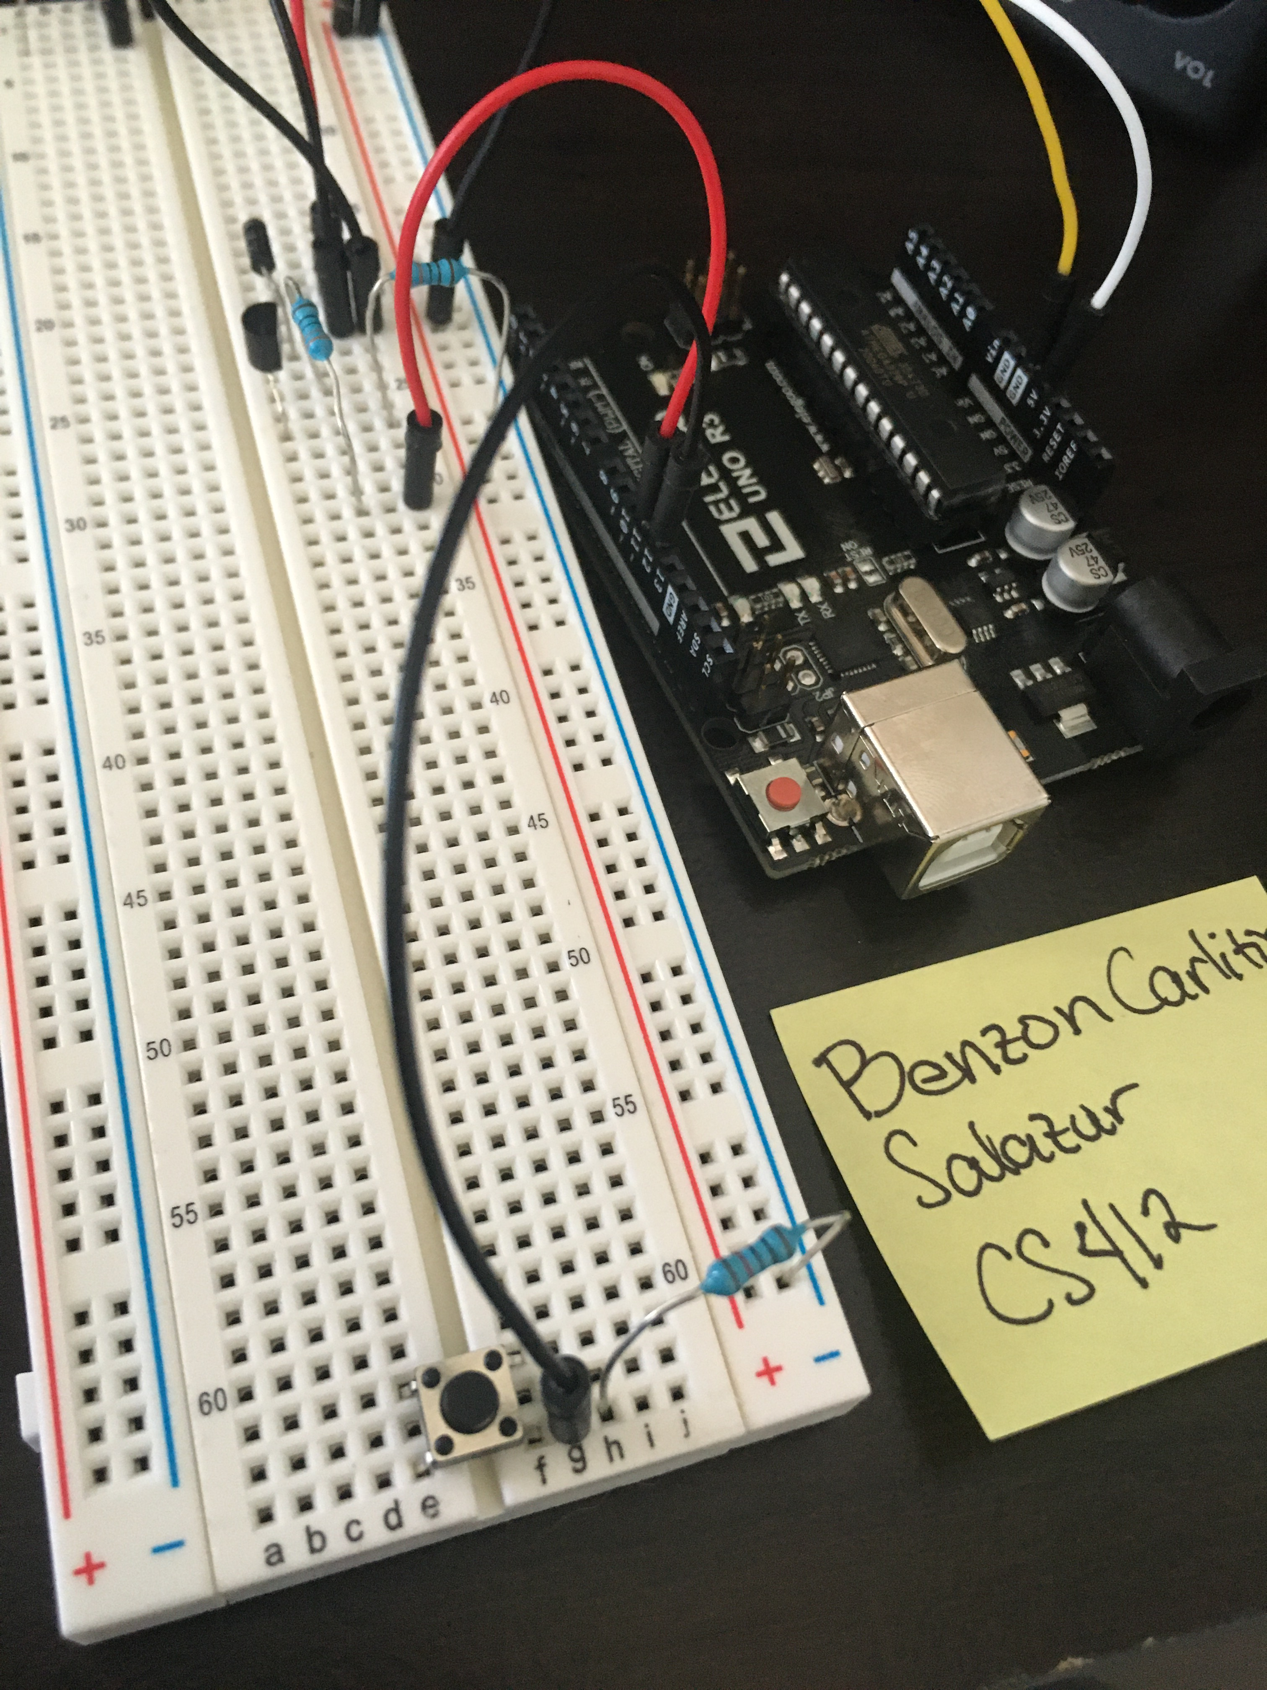

Next, using another jumper wire, connect terminal A (upper right corner) of the button to the 5V pin on the breadboard.

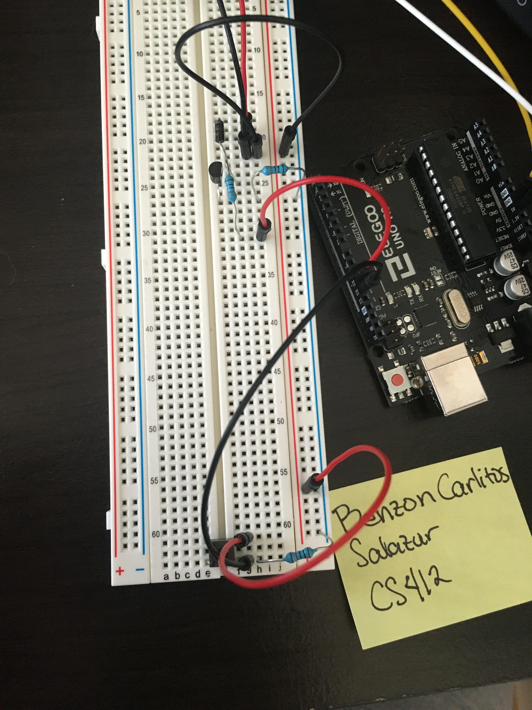

Connect your Arduino to your computer via the USB cable, and run the code below.

# Code:

const int motor = 11;

const int button = 12;

int value = 0;

void setup() {

// put your setup code here, to run once:

pinMode(button, INPUT);

pinMode(motor, OUTPUT);

Serial.begin(9600);

}

void loop() {

// put your main code here, to run repeatedly:

value = digitalRead(button);

if(value > 0){

digitalWrite(motor, HIGH);

}else {

digitalWrite(motor, LOW);

}

}

# Explanation:

The code and the setup is pretty simple, except that we had to switch the motor for an LED. We have two pins we are using, pin 11 for the motor, and pin 12 for the button. The button is the input and the motor will be the output. The idea is that when the button is pushed, the motor should spin, or in this case, the LED will light up.